Nordstrom Virtual Barista
The future of fashion & coffee.
Contents
1 Introduction 3
1.1 Business Requirements 3
1.1.1 Coffee is ready when the customer is ready. 3
1.1.2 Stores can anticipate busy times. 3
1.1.3 Stores can view metrics on usage, location. 3
2 Technical Considerations 3
2.1 Security Risks 3
2.1.1 Risk 1: Unauthorized Baristas 3
3 User Stories 4
3.1 As a customer, I want to register an account so that I can order coffee. 4
3.2 As a customer, I want to sign in to the system. 4
3.3 As a customer, I want to browse the coffee pickup locations near me. 4
3.4 As a customer, I want to view the current wait time at all coffee pickup locations near me. 4
3.5 As a customer, I want to order coffee to be picked up at a specific location and time. 4
3.6 As a customer, I want to view my active orders. 4
3.7 As a customer, I want to cancel an active order that has not yet been started. 4
3.8 As a barista, I want to register an account so that I can work shifts. 5
3.9 As a barista, I want to sign in to the system so that I can begin my shift. 5
3.10 As a barista, I want to view a list of incoming orders for my work location. 5
3.11 As a barista, I want to make a customer’s order. 5
3.12 As a barista, I want to view the average hourly order volume for a specific location and day of the week so that I can anticipate busy times. 5
3.13 As a business owner, I want to view a report showing the order totals over the past 30 days at all locations. 5
4 Candidate Solution 6
4.1 Conceptual Architecture Diagram 6
4.2 Customer UI 7
4.2.1 Home Page 7
4.2.2 Register 8
4.2.3 Browse Locations 9
4.2.4 Create Order 10
4.2.5 My Orders 11
4.3 Barista UI 12
4.3.1 Barista Home Page 12
4.3.2 Barista Registration 13
4.3.3 Barista Process Orders 14
4.3.4 Barista Order Detail 15
4.3.5 Demand by Hour 16
4.4 Business Owner UI 17
4.4.1 Orders Report 17
5 Appendix A – Data Model 17
5.1 User 17
5.1.1 UserID 17
5.1.2 DefaultOrderDetails 17
5.2 Order 19
5.2.1 OrderID 19
5.2.2 UserID 19
5.2.3 LocationID 19
5.2.4 Details 19
5.2.5 CreatedAt 19
5.2.6 PickUpAt 19
5.2.7 CancelledAt 19
5.2.8 StartedAt 19
5.2.9 CompletedAt 19
5.3 Location 19
5.3.1 ID 19
5.3.2 Name 19
5.3.3 Latitude 19
5.3.4 Longitude 19

Introduction
Nordstrom Virtual Barista empowers customers to order their perfect cup of coffee and have it made ready for them to pick up at their convenience.

Business Requirements

Coffee is ready when the customer is ready.
To achieve this requirement we can do two things:
- Allow the customer to specify their desired pickup time.
- Track the average time between order creation and completion for the past hour so we can inform the customer of the current wait time.
  - A more precise measurement of current projected wait time will be data driven. In other words, as we collect usage data we can analyze tat data to discover other signals which predict real-world wait time.

Stores can anticipate busy times.
To achieve this requirement we can do a few things.
- As we track usage over time we will be able to project demand on any given day by looking at the historical demand profile for that date, day of the week, promotion or other factors.
- Moment to moment we can monitor the order queue and alert when the volume of incoming orders exceeds a threshold.
- We can anticipate any orders which may fail to be made in time by comparing the current wait time to the pickup time of incoming orders. If we allowed an order into the system which does not look like it will be made in time, we can send the customer an alert.

Stores can view metrics on usage, location.
We will capture each order along with the location and other relevant stats. For more info see Appendix A – Data Model.

Technical Considerations

Security

Risk 1: Unauthorized Baristas
There is a risk that an unauthorized person could sign in as a barista and begin removing customer’s orders in the queue. We must ensure that all the orders shown are specific to the location in which the barista is working, and that the barista is on duty at that location at that time. One way to achieve these is to include shift scheduling as a feature of the app. This way, a manager authorizes a barista to work at a specific time and location.
Additional measures which may be used to reinforce validating the location and time that the barista is pre-authorized to work include location detection, native apps, client certificates, location specific barcodes, sign in requiring manager approval, etc…

Localization
We may wish to consider localizing the app into foreign languages. The most popular languages to start with are French, Spanish, German, Japanese and Italian.

Accessibility
We will design to accommodate customers and employees with disabilities.

Performance
Best practices for achieving high performance will be utilized to ensure application servers are quick to respond and client performance is optimized.

Monitoring
Real-time metrics of performance, usage and errors will ensure that any outages or degradation in service quality are detected quickly so that they can be remedied.

Scalability
The design of the system must allow it to be scaled to support millions of users and employees by the addition of production hardware.

Usability
Usability studies on interface options may inform us of ways to ensure the successful adoption of the system.

User Stories

As a customer, I want to register an account so that I can order coffee.
See Register.

As a customer, I want to sign in to the system.
See Home Page.

As a customer, I want to browse the coffee pickup locations near me.
See Browse Locations.

As a customer, I want to view the current wait time at all coffee pickup locations near me.
See Browse Locations.

As a customer, I want to order coffee to be picked up at a specific location and time.
See Create Order.

As a customer, I want to view my active orders.
See My Orders.

As a customer, I want to cancel an active order that has not yet been started.
See My Orders.

As a barista, I want to register an account so that I can work shifts.
See Barista Registration.

As a barista, I want to sign in to the system so that I can begin my shift.
See Barista Home Page.

As a barista, I want to view a list of incoming orders for my work location.
See Barista Orders.

As a barista, I want to make a customer’s order.
See Barista Order Detail.

As a barista, I want to view the average hourly order volume for a specific location and day of the week so that I can anticipate busy times.
See Demand by Hour.

As a business owner, I want to view a report showing the order totals over the past 30 days at all locations.
See Orders Report.

Candidate Solution

Conceptual Architecture Diagram
The following diagram shows a conceptual view of the candidate system architecture.
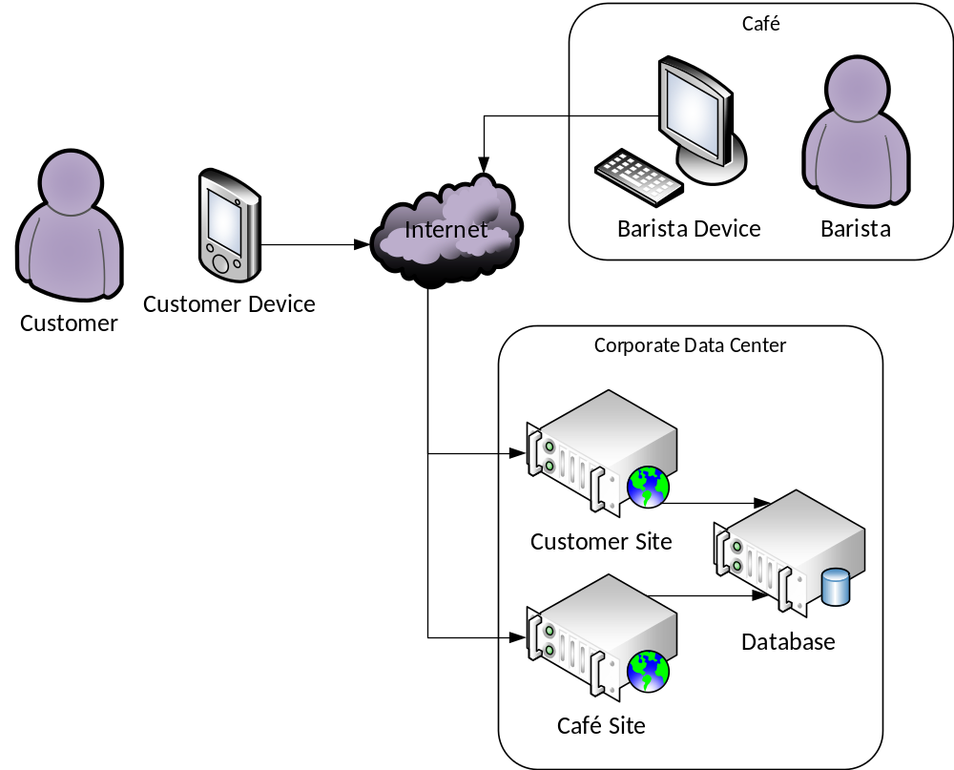
Splitting the customer and café sites into different servers is recommended as it makes it easier to control access to features requiring authorization and allows us to scale the services proportionately.

Customer UI

Home Page
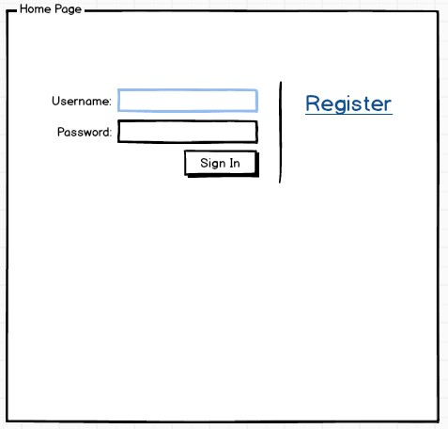

Register
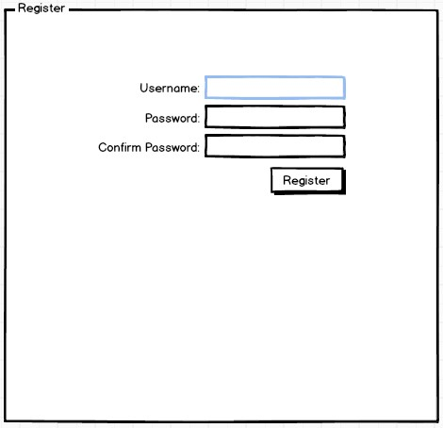

Browse Locations
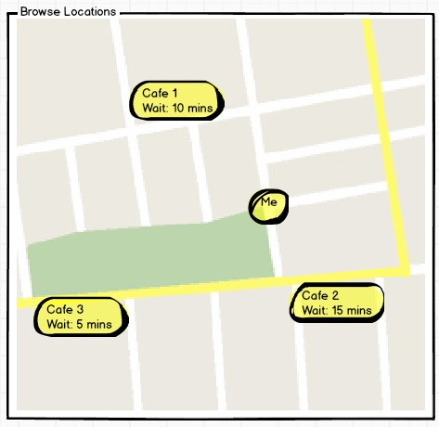
The map view is the core of this application. It allows customers to quickly and easily see locations near them and choose a location based on their planned activities and desired pickup time. In addition to showing where the locations are on a map, we show the current wait time.

Create Order
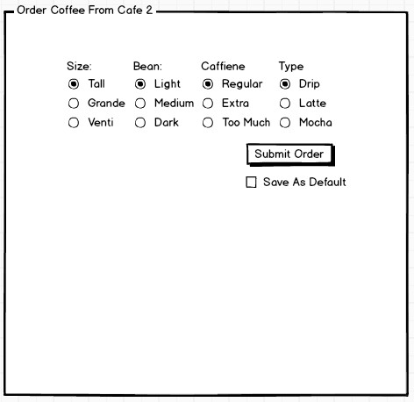
Given the complexity of coffee orders, designing a usable order control will be a challenge, especially on a mobile device where screen space is limited. It is essential not only that the customer be able to design their perfect cup of coffee, but that the order produced be posted to the system in a standard format so that the barista has no question of what the customer wants. It is recommended that we engage usability experts to test a variety of UIs to determine what would be most usable.

My Orders
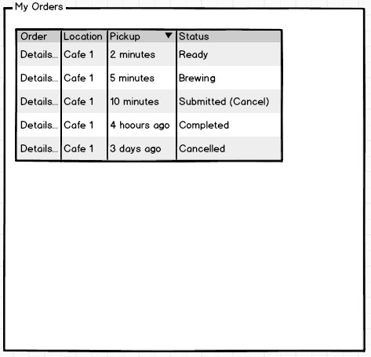
On the My Orders screen, the customer can see their recent orders along with their status. Customers can choose to cancel an order which has not yet been started. It is recommended that we use something like ajax, WebSockets or a native app to update the status here without the customer having to reload the screen.

Barista UI

Barista Home Page
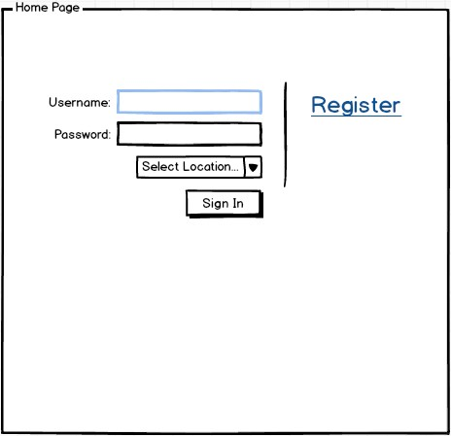

Barista Registration

Barista Process Orders
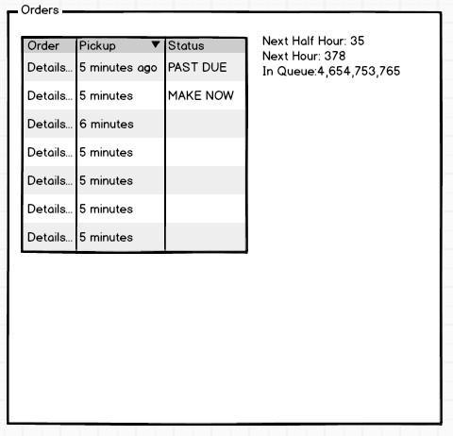
The Process Orders screen is where the barista receives orders. It also gives the barista the ability to predict how busy they will be. It is recommended that we use something like ajax, WebSockets or a native app to update the orders here without the customer having to reload the screen.

Barista Order Detail
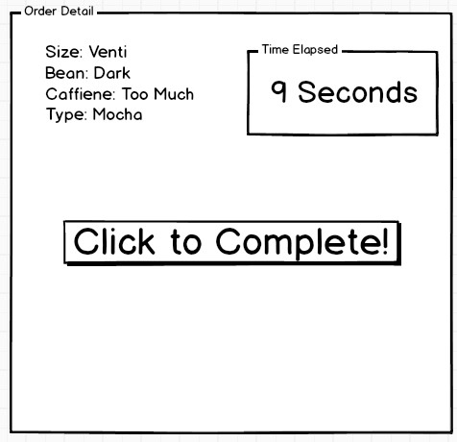

Demand by Hour
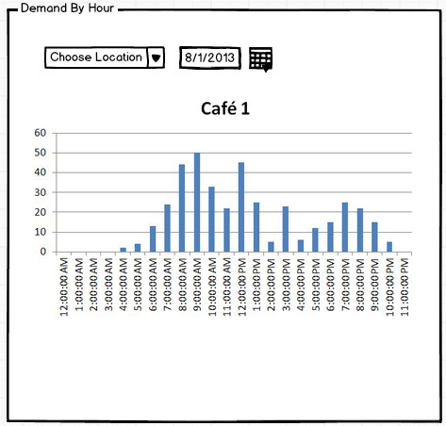

Business Owner UI

Orders Report
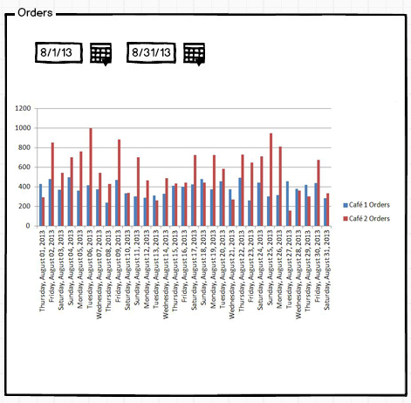

Appendix A – Data Model

User

UserID

DefaultOrderDetails
Further research is required to determine the optimum storage format for customer order details. Options include:

Free Text
With this option, we allow the customer to type in their order exactly as they would say it to a barista at a café offline.
Advantages:
- Easiest to implement
- Easy for the customer to order
Disadvantages:
- Inconsistent. The barista may not understand the order and we may not get the customer’s order right as a result.
- No opportunity to show the customer all options.
- Difficult to analyze historical data.

Normalized Relational Schema
This is the recommended option. We do the research to determine every possible option for ordering coffee, and group/normalize these into a relational schema which exists in the database.
Advantages:
- Consistency. Every order will be make-able and the barista will know exactly what the customer ordered. Customers will have complete control over all details of their order
- We can update the menu by adding and removing options at any time (potentially via a management UI).
- Order data will be easy to analyze later.
Disadvantages:

Order

OrderID

UserID

LocationID

Details

CreatedAt

PickUpAt

CancelledAt

StartedAt

CompletedAt

Location

ID

Name

Latitude

Longitude

